app\system\permission\admin\MemberAdmin.class.php, There are no protective measures in doAddSave() Only checkUniqueMember was performed, empty to check if it is duplicate and empty with existing information文本

Click to add a member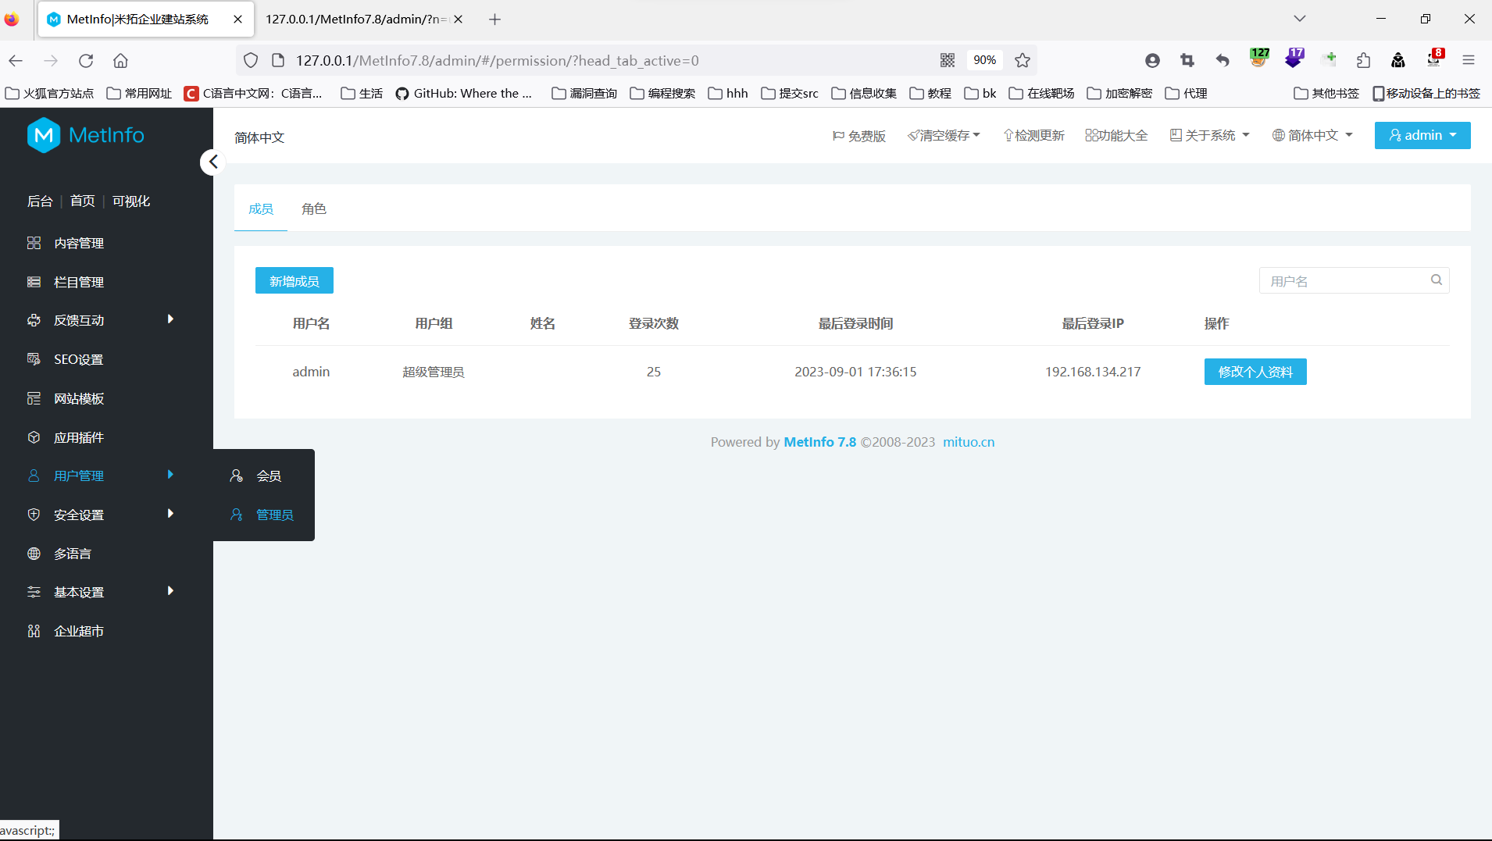

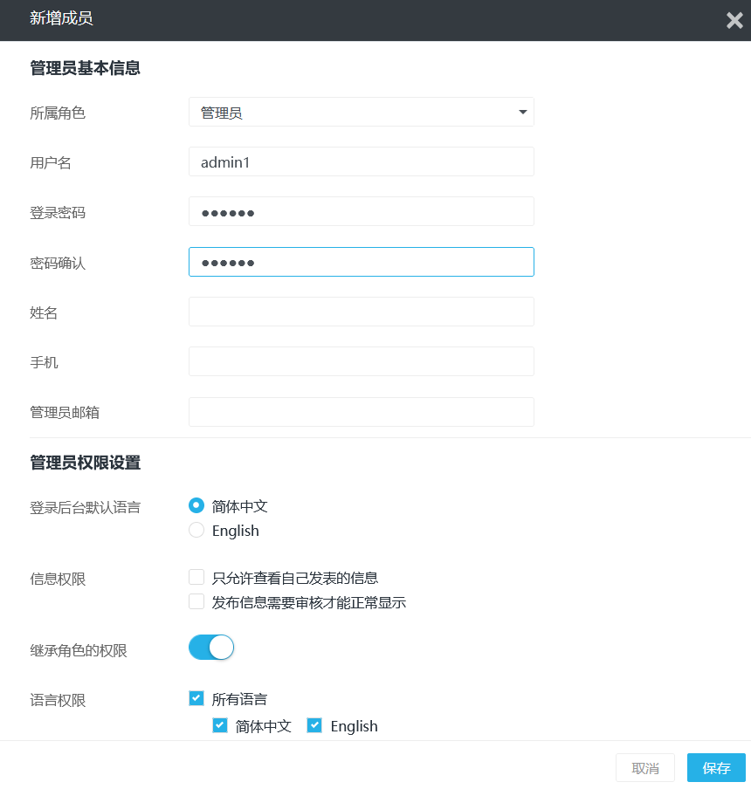

Add admin1 123456

The following permissions can be selected by oneself

Packet capture

The first package is then sent to burp to quickly build csrf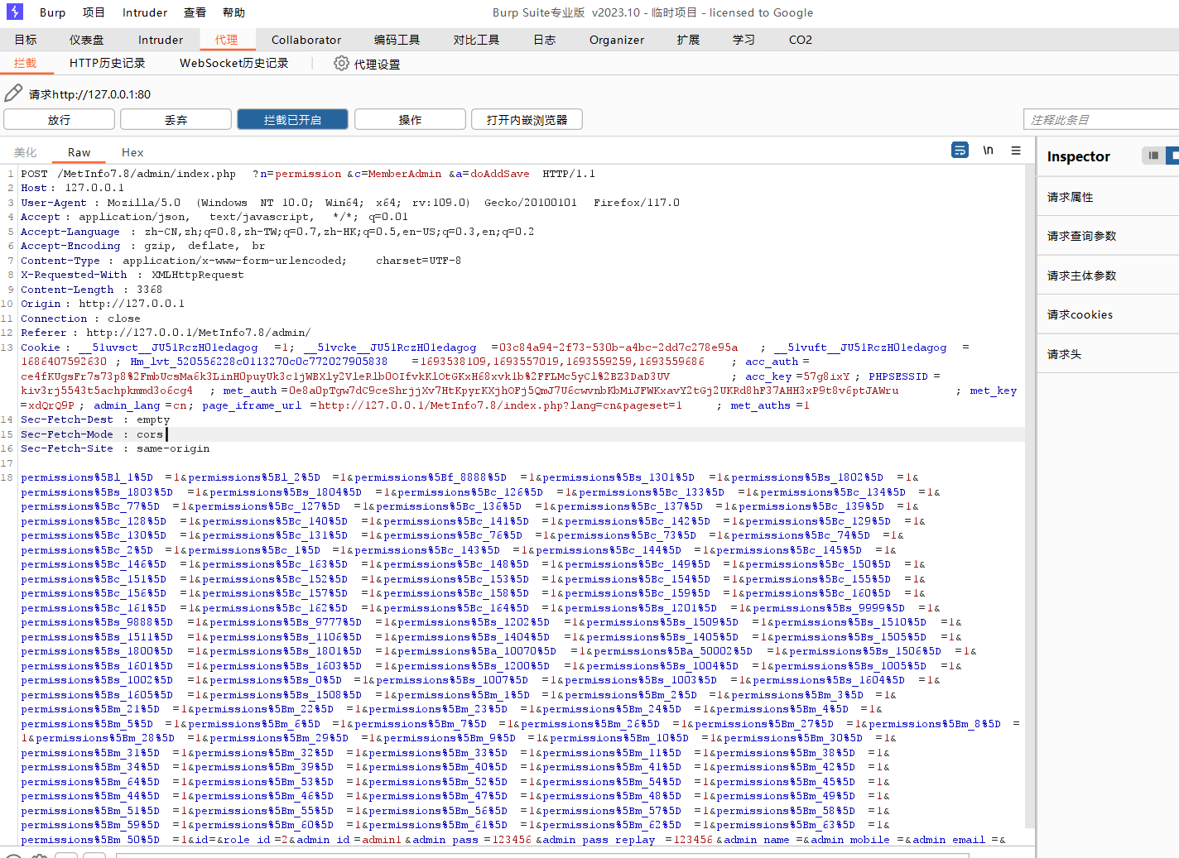

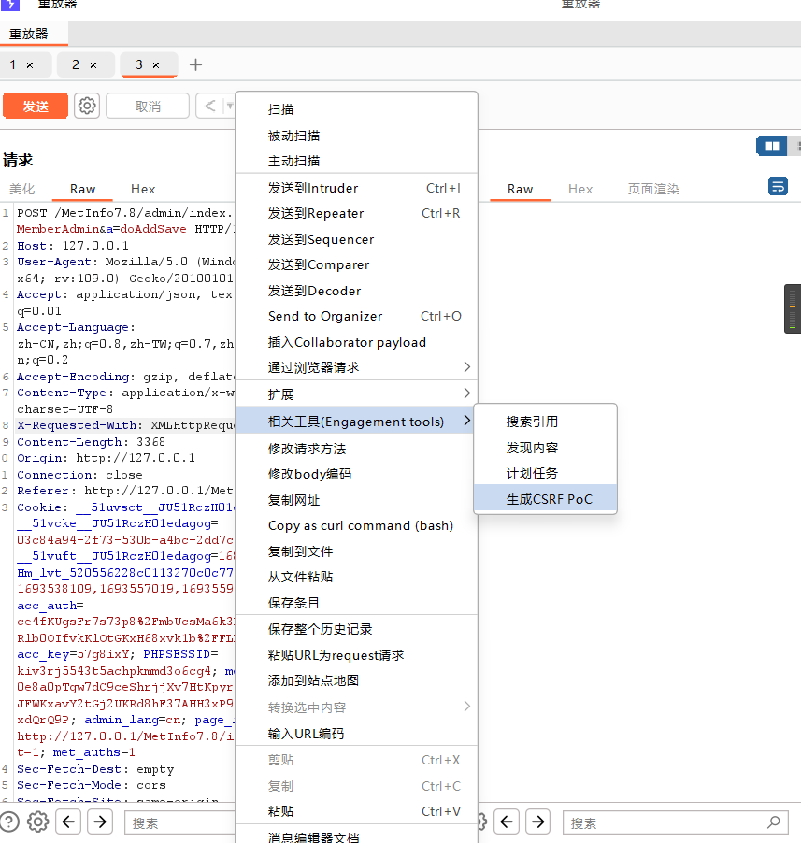

Place the built code into an HTML file with a path of http://192.168.134.217/csrf.html

Replace admin1 with the user you want to add, and other permissions can also be modified by yourself

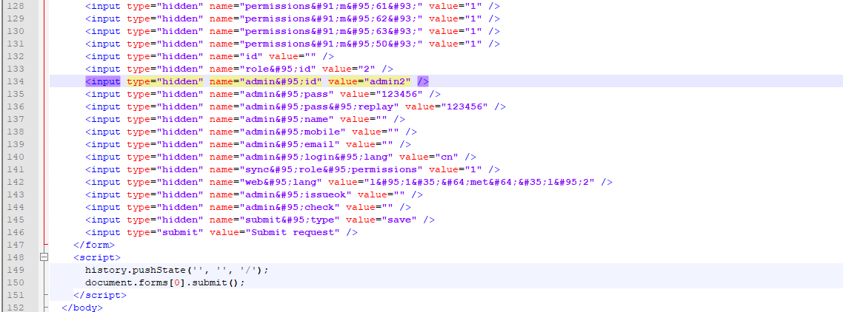

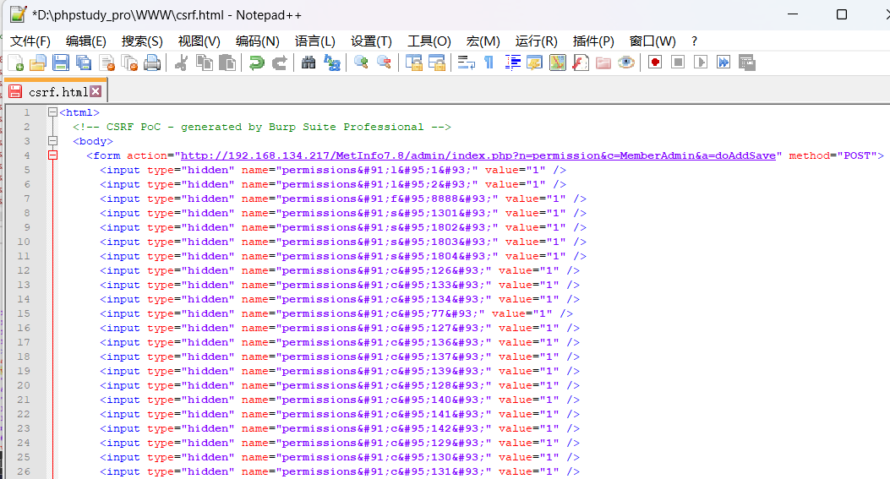

I replaced 127.0.0.1 with http://192.168.134.217

Access after logging in to admin http://192.168.134.217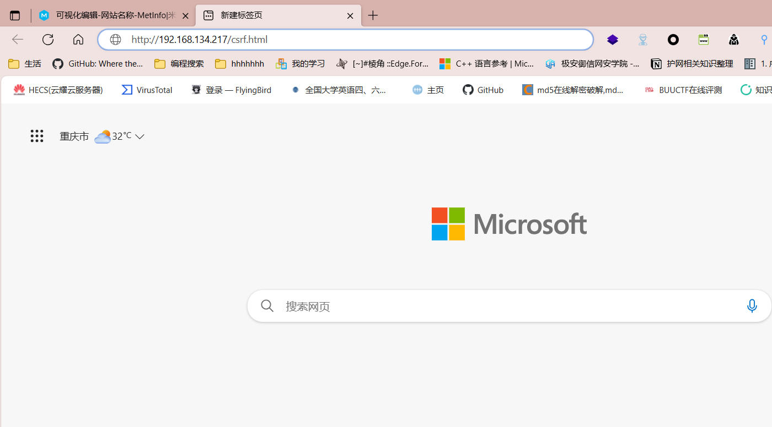

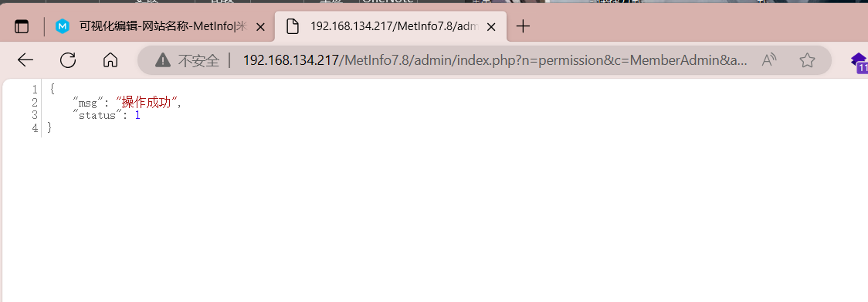

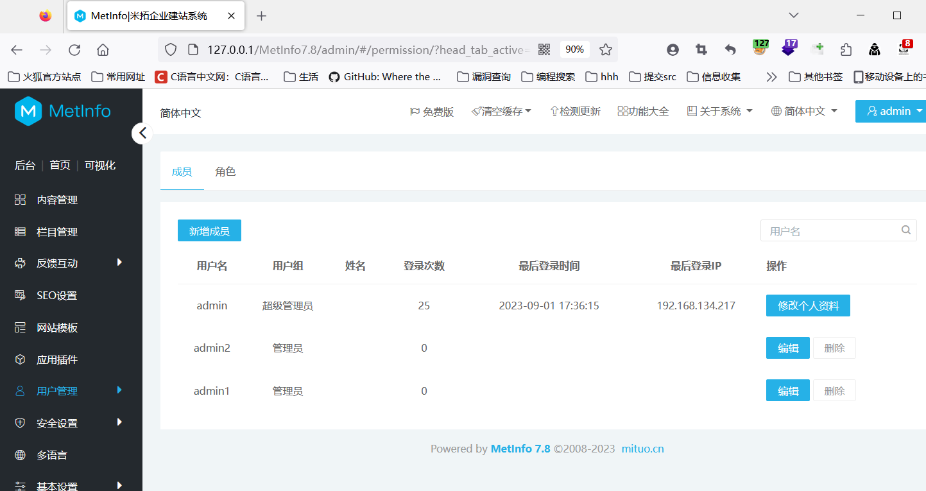

Successfully added admin2